Project Design Phase-II
Data Flow Diagram & User Stories

Date | 29 September 2026
Team ID | 6ab3d2b20fc666a751b3505e
Project Name | AI blogNest API
Maximum Marks | 4 Marks

Data Flow Diagrams:
A Data Flow Diagram (DFD) is a traditional visual representation of the information flows within a system. A neat and clear DFD can depict the right amount of the system requirement graphically. It shows how data enters and leaves the system, what changes the information, and where data is stored.

Example: (Simplified) 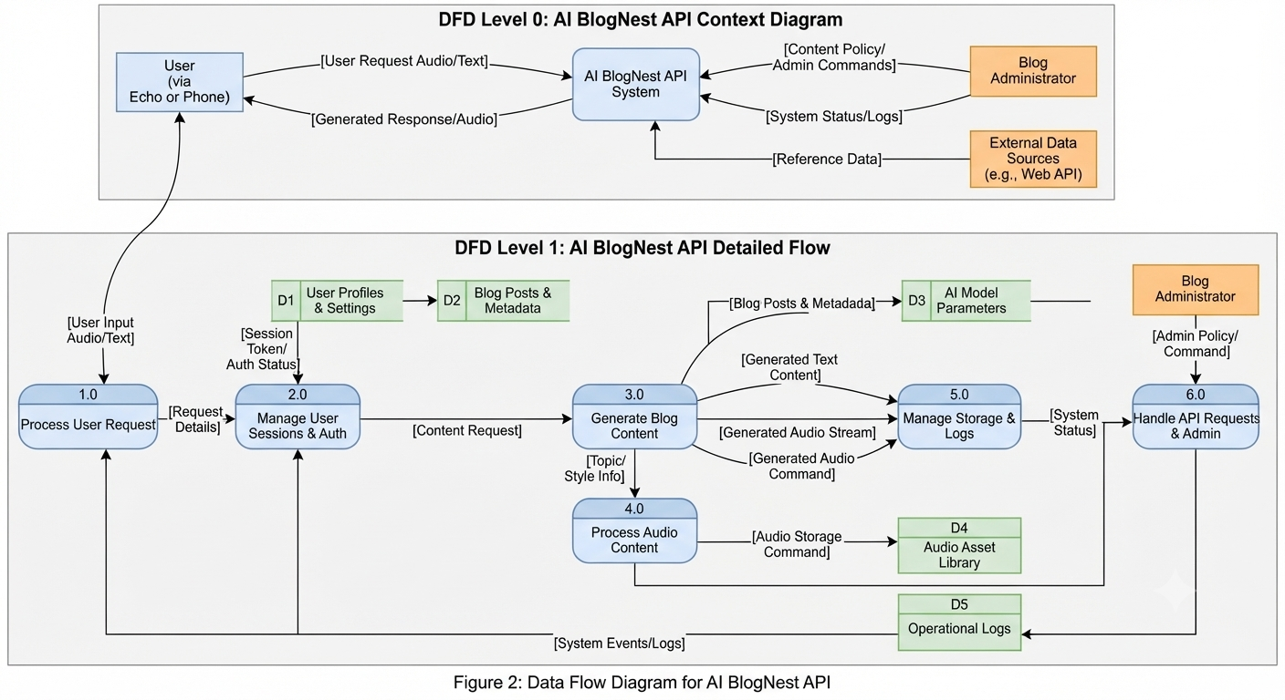

User Stories
Use the below template to list all the user stories for the product.
User Type | Functional Requirement (Epic) | User Story Number | User Story / Task | Acceptance criteria | Priority | Release
Customer (Mobile user) | Registration | USN-1 | As a user, I can register for the application by entering my email, password, and confirming my password. | I can access my account / dashboard | High | Sprint-1
 |  | USN-2 | As a user, I will receive confirmation email once I have registered for the application | I can receive confirmation email & click confirm | High | Sprint-1
 |  | USN-3 | As a user, I can register for the application through Facebook | I can register & access the dashboard with Facebook Login | Low | Sprint-2
 |  | USN-4 | As a user, I can register for the application through Gmail |  | Medium | Sprint-1
 | Login | USN-5 | As a user, I can log into the application by entering email & password |  | High | Sprint-1
 | Dashboard | USN-6 | As a mobile user, I can view my generated blog posts and audio logs on my dashboard. | I can see a list of my AI-generated posts and play audio content. | Medium | Sprint-2
Customer (Web user) | Content Generation | USN-7 | As a web user, I can submit a voice or text prompt to generate blog content via the BlogNest API | The system returns generated text and audio stream successfully. | High | Sprint-1
Customer Care Executive | Support Management | USN-8 | As a support executive, I can view user system logs and request history to troubleshoot issues. | I can access error logs and user activity via the admin panel. | Medium | Sprint-3
Administrator | System Administration | USN-9 | As an administrator, I can manage AI model parameters, content policies, and system settings | I can update API settings and monitor system logs without errors. | High | Sprint-2

